All About Me

A photo or drawing of me

Name: Preferred Name:

Age: Pathway: Location:

My preferred pronouns: he/him she/her they/them

Religion:

My Normal Routine
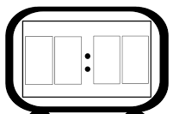

I got to sleep at: I wake up at:

How easy do I find it to fall asleep?

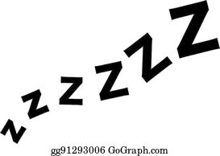
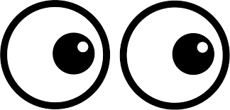

Do I take medication to help me sleep?
……………………………………………………………………………………………………………………………………………………………………………………………………………………………………………………………………………………………………….

What is my normal sleep routine? (Do I wake in the night? Do I have a bedtime routine? Do I use technology at night? etc)
……………………………………………………………………………………………………………………………………………………………………………………………………………………………………………………………………………………………………………………………………………………………………………………………………………………………………………………………………………………………………………

Do I eat breakfast in the morning? Yes / No

What is my normal morning routine? ………………………………………………………………………………………………………………………………………………………………………………………………………………………………………………………………………………………………………………………………………………………………………………………………………………………………………………………………………………………………………………………………………………………………………………………………………………
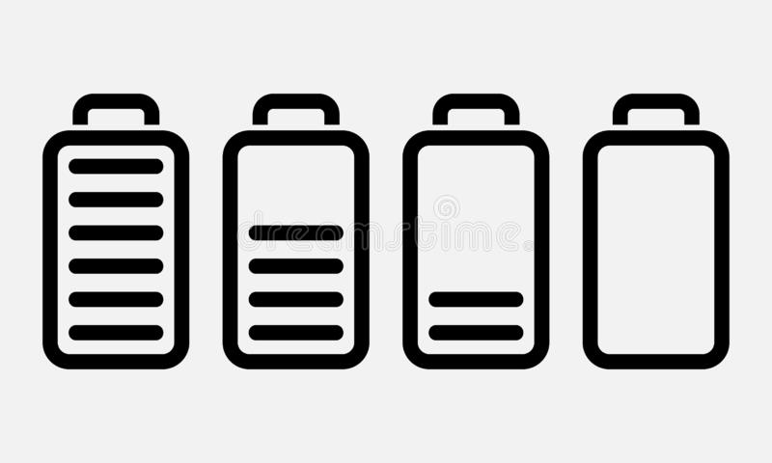
How much energy do I have during the day?

My Relationships

Do I like to spend time with my family? Yes / No

Who do I live with? …………………………………………………………………………………………………………………………………………………………………………………………………..
The people in my family I am closest to:

Do I like to spend time alone or with others?

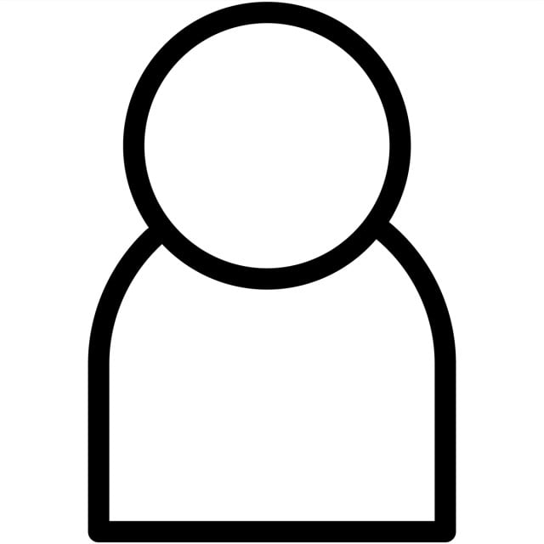
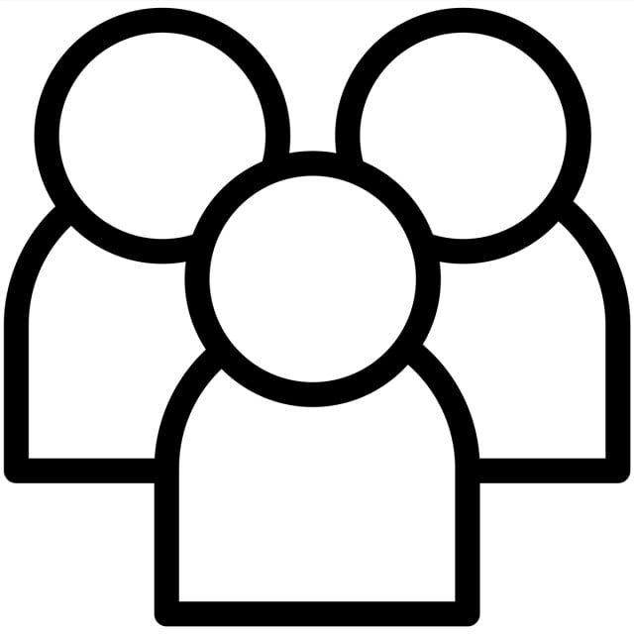

Do I have friends? Yes / No

Do I like to spend time with my friends? Yes / No
Activities I like to do with friends:

Do I have a boyfriend or girlfriend? Yes / No

Do I have imaginary friends? Yes / No Their names are ………………

Do I talk to myself? Yes / No

My Hobbies and Interests
What interests and hobbies do I enjoy?

How many hours do I spend on my hobbies and interests in a typical week?


….. ….. ….. …… ….. …… ……
M T W Th F S S

My favourite songs are: | My favourite things to watch are:

Places I like to go: | Places I do not like to go:

Eating and Drinking

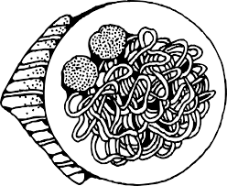
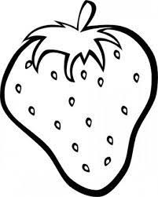
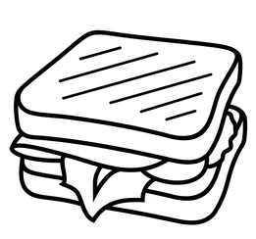
What meals do I eat?
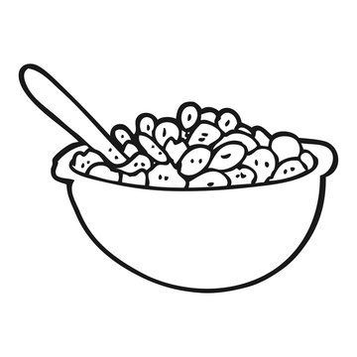
Breakfast Lunch Dinner Snacks

Foods I like | Foods I don't like | Drinks I like | Drinks I don't like
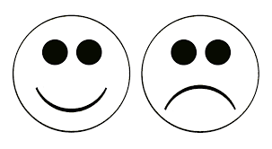
Do I like eating and drinking?

I like (don’t like) my food cooked or presented like this ………………………………………………………………………………………………………………………………………………………………………………………………………………………………………………………………………………………………………

How I eat / drink (cutlery / finger foods / cup / bottle etc) ………………………………………………………………………………………………………………………………………………………………………………………………………………………………………………………………………………………………………

Can I cook for myself / make myself drinks? …………………………………………………………………………………………………………………………………………………………………………………………………….

Staying Active

What do I do to stay physically active?
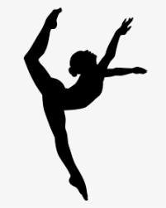
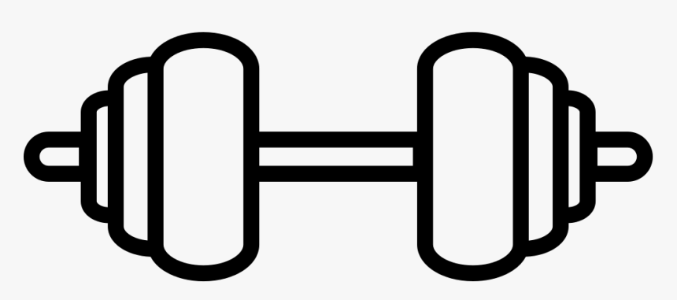
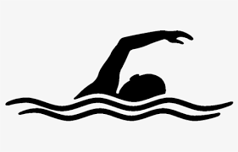
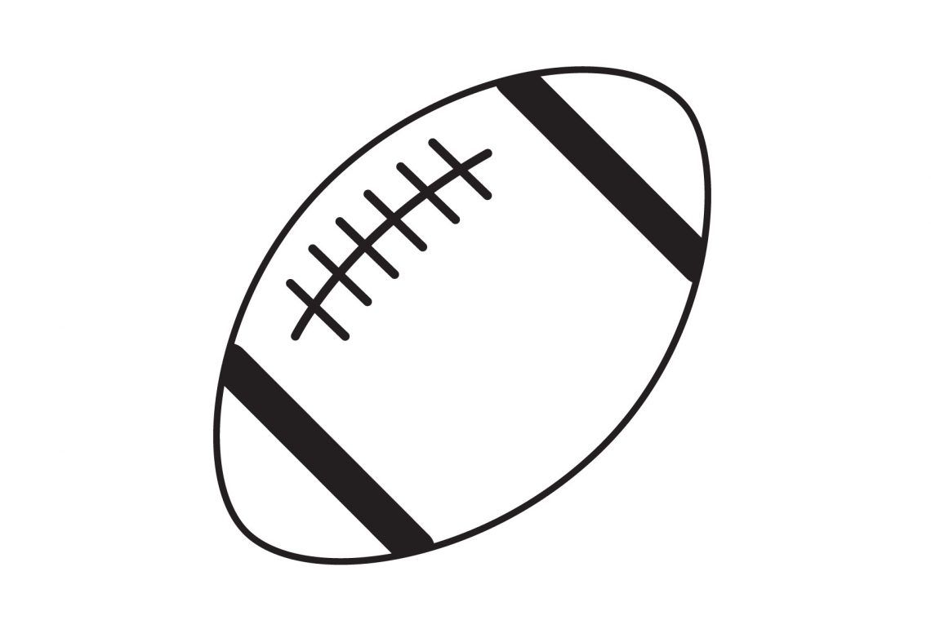
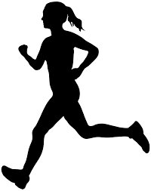
Other:

How often do I exercise? …………………………………………………………………………………………………………………………………………………………………………………………………….

Do I enjoy exercising?

Do I have any physiotherapy needs? …………………………………………………………………………………………………………………………………………………………………………………………………………………………………………………………………………………………………………………………………………………………………………………………………………………………………………………………………………………………………………….
Physical activities I like / dislike:

Details of my fine and gross motor skills …………………………………………………………………………………………………………………………………………………………………………………………………………………………………………………………………………………………………………………………………………………………………………………………………………..
Looking After Myself

Is my appearance important to me? Yes / No

Am I concerned about what other people think of my appearance? Yes / No

How often do I shower or bathe?

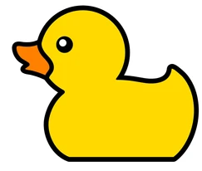
M T W Th F S S

Do other people have to tell me when to shower or bathe? Yes / No

Do I need help to shower or bathe? Yes / No

A description of my personal care needs and how best to support me ……………………………………………………………………………………………………………………………………………………………………………………………………………………………………………………………………………………………………………………………………………………………………………………………………………………………………………………………………………………………………………..

How often do I change my clothes?

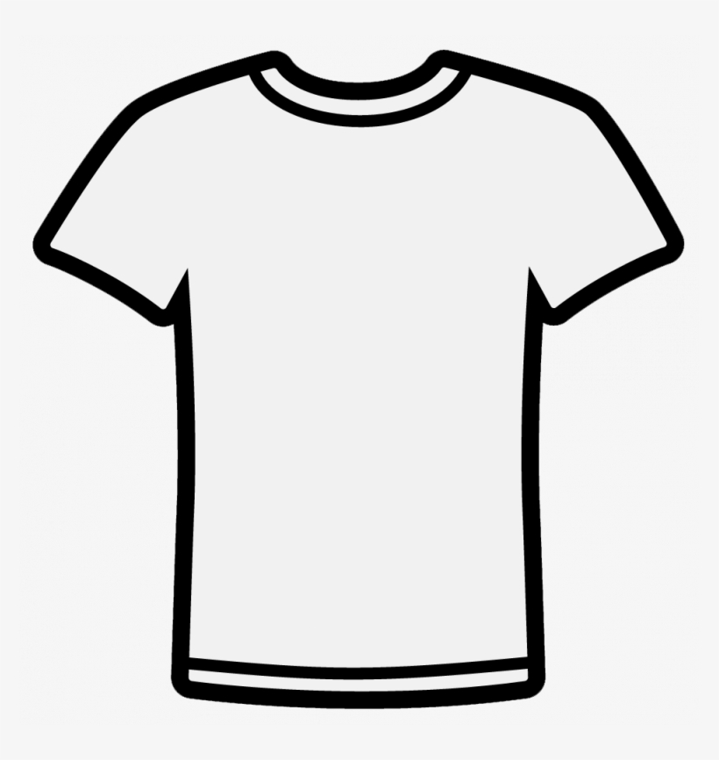
M T W Th F S S

Do other people have to tell me when to change my clothes? Yes / No

Do I need support to help me change my clothes? Yes / No

What support do I need to help me change my clothes? ……………………………………………………………………………………………………………………………………………………………………………………………………………………………………………………………………………………………………….

Am I able to do my own laundry? Yes / No
My Healthy Mind

Do I have mental health needs? Yes / No

Do I take medication for my mental health needs? Yes / No

Things that scare me or make me anxious | How to comfort me and reduce my anxieties
Things that make me happy:

A description of my sensory needs (do I like a quiet space / ear defenders? Do I dislike bright lights? Do labels on clothes irritate me? etc) ………………………………………………………………………………………………………………………………………………………………………………………………………………………………………………………………………………………………………………………………………………………………………………………………………………………………………………………………………………………………………………………………………………………………………………………………………………

Decision Making and Choices

Do I find it difficult to make decisions for myself? Yes / No

Who helps me make decisions? …………………………………………………………………………………………………………………………………………………………………………………………………………………………………………………………………………………………………………………………………………………………………………………………………………

How do I make choices? (symbols, pictures, verbally, written, objects etc) …………………………………………………………………………………………………………………………………………………………………………………………………………………………………………………………………………………………………………………………………………………………………………………………………………..

Medical Needs

Do I have any medical needs? Yes / No

What are my medical conditions?
…………………………………………………………………………………………………………………………………………………………………………………………………………………………………………………………………………………………………………………………………………………………………………………………………………

Do I need to take medication at home / college?
…………………………………………………………………………………………………………………………………………………………………………………………………………………………………………………………………………………………………………………………………………………………………………………………………………

Can I manage my medical needs myself? …………………………………………………………………………………………………………………………………………………………………………………………………………………………………………………………………………………………………………………………………………………………………………………………………………

Do I have any allergies?

